
May 2016
Newsletter
Road Race Special
He’s thanked everyone who helped him … but the whole club owes a huge debt to road race organiser Mark Smart who pulled off another successful big VCN Road Race day this year. And then wrote about it:

It was quite a day.

It all started about 9 months ago with me registering the event with BC and the Eastern Road Racing League.
As ever the last month was the busiest with trying to finalise the riders lists, the marshals and accredited marshal and along list of other bits and pieces that need to be in place for an event to run smoothly.
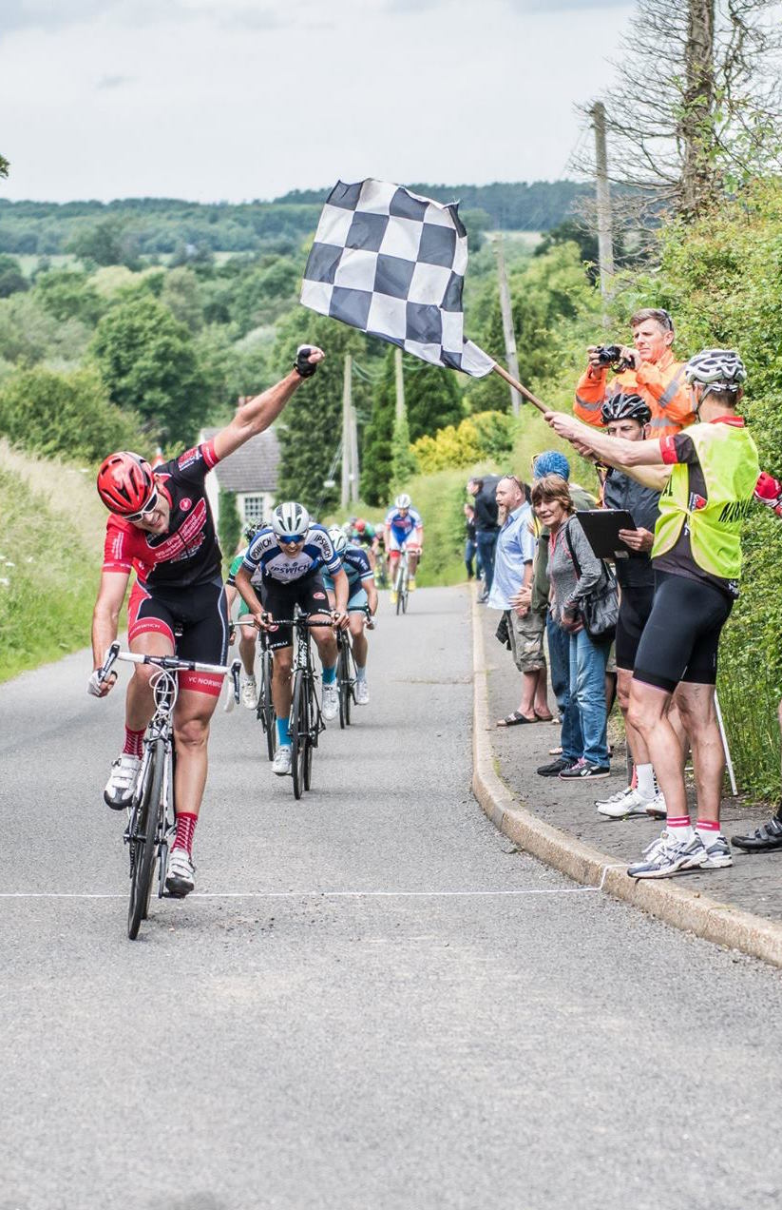
On the Friday I had received an email from Rob Strong that the course had suffered some significant rainfall over the preceding days and was in a quite a state, so the first thing I loaded up before heading out was a spade and a stiff brush. On arriving that evening and after looking around the route there was quite a bit of debris on the road. One area in particular took about 45 minutes of shovelling and sweeping to get the 50mm, that’s 2 inches to some of us, layer of sand and soil off the route.
I finally got back to the village hall at about 9.30 to find that Jen had been busy and had the hall all laid out and ready to go for the morning.
The morning of the event arrived and I was relieved to find the weather looking good.
Over the next few hours things started to fall together, signs went up, marshals and riders arrived, I started to relax and allow the team to do there appointed jobs, which they all did brilliantly.
The men’s race was very eventful with commissaires and riders having to deal with quite a few problems, including four pea viners that were being moved which took up all of the road, a couple of crashes, keeping Rob busy as first aid marshal, a rider with no bar ends who got a formal warning much to his surprise and horror.
The race was very quick, one rider who regularly races on the continent told me that it was the quickest race that he had done in the UK and the continent this year, averaging close to 27mph.
Pic: Natural Photography

The two exciting points for me were the primes lap and the finish, helped I am sure by the fact that these were the only bits I saw! On the primes lap the rider who looked over his right shoulder, thought he was clear and then backed off, learnt a hard lesson, you only back off after crossing the line. He had missed seeing the rider sprinting past him on the left and could react only with a classic look of annoyance.
The finish was great as well. We had seen our boys from VCN all working together and regularly pulling back breakaway groups. It was a really proud moment when through the lens of the camera that I was holding on the finish line the first person who went through was in red and black, later learning it was our own Lewis Pendle. A great result for the club!
Similarly the ladies were very quick as well. It was well fought and raced but ultimately dominated by the riders from London who worked together, continuously attacking the bunch, and, no surprise, winning the race. Fortunately for the Commissaires and the team working with them had fewer problems to deal with, with only one crash caused by a touch of wheels in the last sprint.

Overall I have only had positive comments back. One of particular note was a rider who had travelled from south London, they thought the race was one of the best they had been involved with this year and wanted to congratulate the team involved. One of the men commented that they thought it had been very well run and the team had dealt with some very challenging situations very well.
We also received very positive comments from our team of Accredited Marshals and National Escort Group.
This to me was the icing on the cake, a good race that everyone enjoyed, was safe and well supported by both the riders and the Club.
Final memory of the day will be Rob Strong running about holding a sign above his head trying to keep dry during the torrential down pour as we collected the signs! We were really lucky with the weather!

I would like to say a huge thank you to everyone who helped make the 25th June the best event yet. In no particularly order:

Graham Price, Fraser Tomsett, John Dimascio -,Geoff Boutell , Neville Everett, Barry Smith
Andy Lane, Richard Allan, Chris Faull, Mark Cozens, Chris Loveday, Matt Baker, Charles Auger, Michael Wild, Nick Kidd, Chris Roughton, Malcolm Brown, Carl Pentney, Matt McGrotty, Dawn Riley, Vicky Ford, Stewart Lyons, Ian Cannell, Jax Cannell, Mark Farrow, Andy Defrates, Louise and Owen Marsden, Des Matthews, Michael Meadows, Steve Rush, Bruce Williams, Owen Marsden, Derek and Jennie Lusher, Ian Doe, Rob Strong, Jen Smart, Will Bamber, Clive Rayner, Rob Smith, Sophie Doe, National Escort riders and anyone else who helped behind the scenes on the day.

As always without you this event would not have happened. Once again thank you for your support and for supporting your club. As to next year, well, we will have to see.

Mark
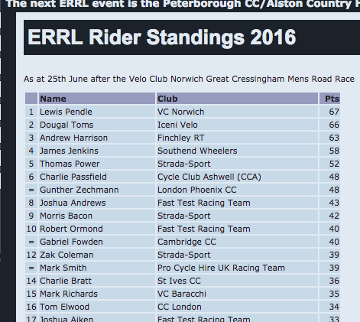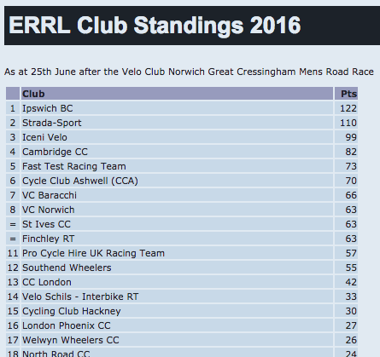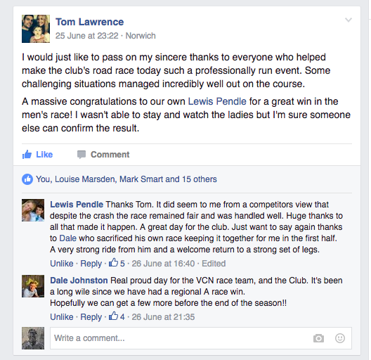

Lou’s road racing notes

Lou Marsden is currently our only regular woman racer:

So I’ve been flying the flag for VC Norwich in women’s road racing both locally and nationally again. It’s been a mixed season for me so far with some really good performances such as finishing in the front group of about 30 in the Lovello Cinelli road race from 80 starters, 15th in the Milton Keynes Road Race and finishing 11th in the East Midlands Road Race Champs. I was annoyed not to be in the front group of 10 and the group I was in was pootling round. I decided I didn’t want to leave it to a sprint so on the last lap I attacked on the climb half way round the 11-mile circuit. Then I was in time trial mode. I didn’t look back once but fully expected the group to come flying past me any time. I just kept pushing hard until the finish and was actually a couple of minutes ahead of them in the end!
I was disappointed that I didn’t feel good for our own race as I was hoping to better my 9th place from last year but we all have off days.
I’ve also been doing a bit more time trialling recently, winning two open 10 mile races and going under 24 minutes for the first time and taking almost 5 minutes off my 25 mile pb.
My next aim is to do well in the National Masters Road Race Champs on August 7th. My goal is a top 10 in my age group after finishing 8th last year.

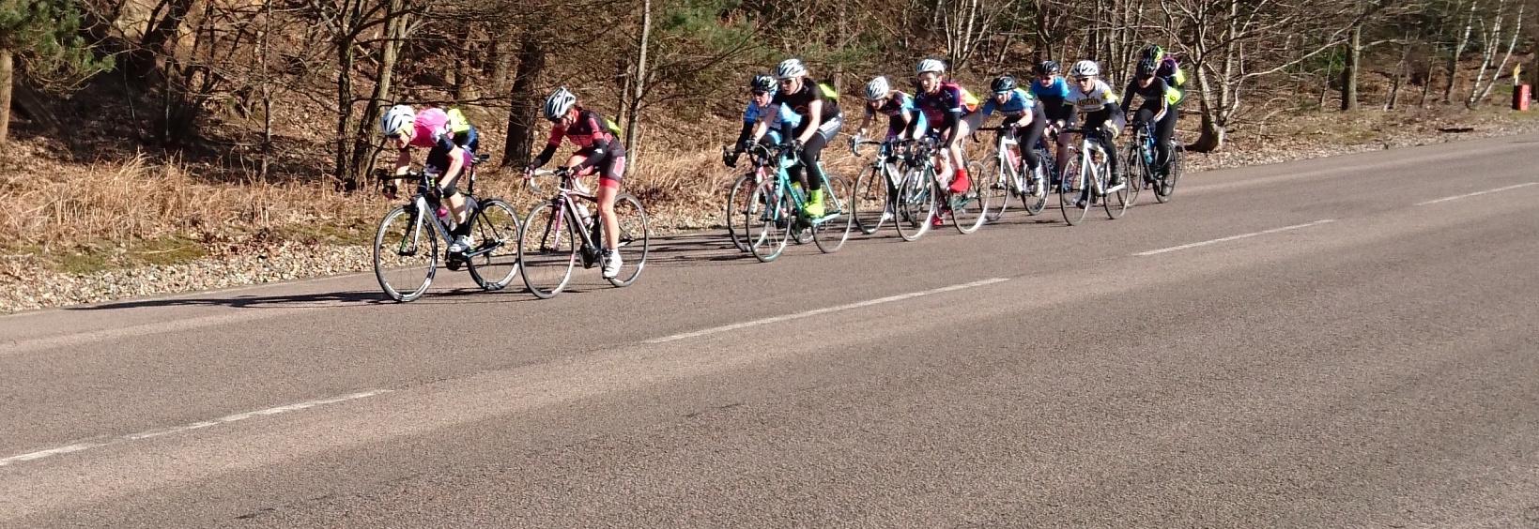
Rossi ride: He liked it so much, he’s doing it again. Roly Cook organised a successful, if rather damp and puncture-prone ride to Maglia Rossi near Bury Saint Edmunds back in May. Hoping for dryer weather and fewer punctures he’s doing another one on Saturday July 16th, 0700 from the Forum at club ride pace. Details on the club Facebook page or PM him on Facebook.
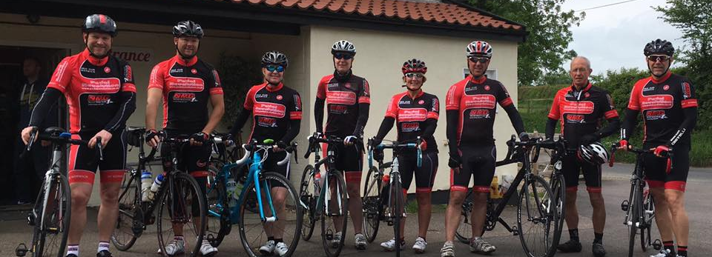
NMG Sportive Trophy
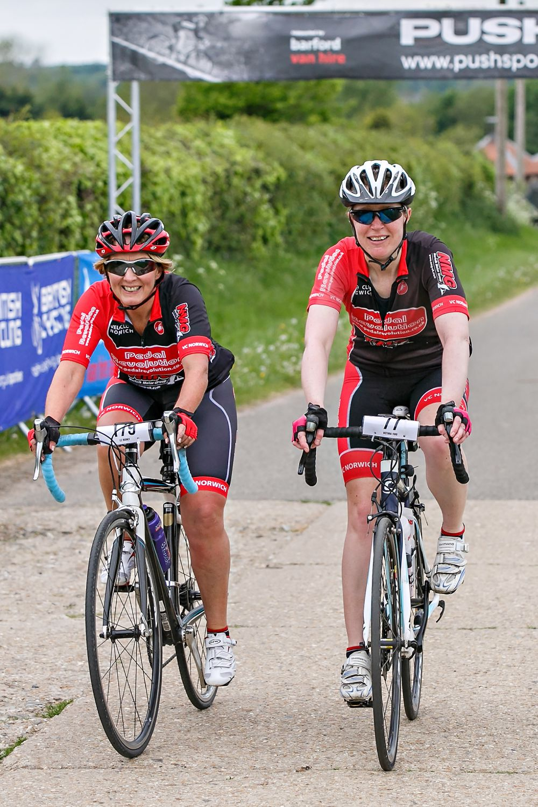
… and then there were five.
Norfolk’s most inclusive cycling club has, on offer, the most inclusive cycling trophy. You don’t have to be fast, you don’t have wear yourself out doing thousand kilometre rides, all you have to do is represent the club in Sportive and Reliability events and the like, finish them and log the miles. We have even set up a separate trophy for Audax riders.

So this month sees a welcome expansion of the field by a full twenty five per cent as Dawn Riley slaps down a marker, more to come I’m sure. The last update introduced Chris Roughton to the field and this time he’s stormed into the lead. But is Paul Dolphin stacking up the miles for a mega-claim to come? Only time will tell.
Vicky Ford chalks up another 100 in Boadicca with Liz Rooney

Pos | RIDER | Events | Total
1 | Chris Roughton | Swarm 100, Boadicca 100, Norwich 100, Diss 9 100 | 551
2 | Vicky Ford | Boudicca 100 | 467
3 | Bob Carter | Boudicca 100 | 350
4 | Paul Dolphin |  | 335
5 | Dawn Riley | Etape Loch Ness 66, 2 EDCA reliabilities 81 | 147

Mileage claims by email please to newseditor@vcnorwich.co.uk (and no other email or I get confused) outlining the event(s) ridden, the date, and the mileage completed. If more than one rider does any event and the mileage claims differ then the judging panel will award the same mileage to all riders, leaning towards the advertised distance.
And if that’s not clear enough, and you’re not sure, do email with any questions.
Winter Drawers On
It’s the annual joke which never gets old. Yet again it’s time to order any winter club kit – with Clive Rayner needing your order by July 22nd, so not long. There’s a long sleeve thermal jersey for £69, the winter jacket for £109 and thermal bid tights for £89. Orders welcome on the Facebook page or email Clive at mailto:chrayner@hotmail.com

What we did on our holidays
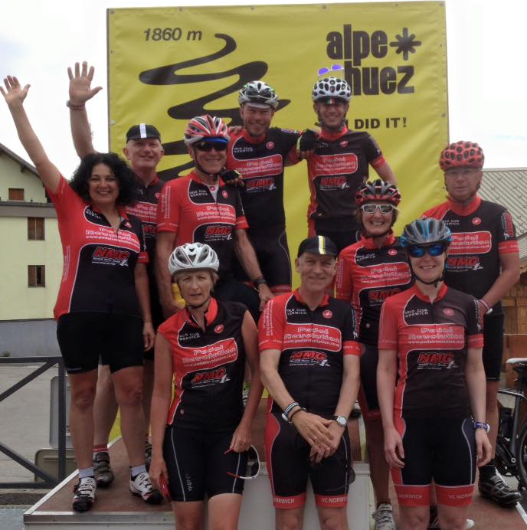
VCN members have been flying the flag internationally over the past couple of months. Two groups in the French Alps and another over the border in Italy have been experiencing what real mountains are like.
And club kit was out in force as the top women riders, including our honorary member Emma Pooley, headed into Norfolk for the finish for the first stage of the Aviva Women’s Tour.
